***Call for evidence:  
National Climate Change  
Risk Assessment 2026***

Information pack

**Submissions open:** 28 November 2024

**Submissions close:** 31 March 2025

**Disclaimer**

This document has been prepared by He Pou a Rangi Climate Change Commission (the Commission) to provide background information that supports public participation in its call for evidence relating to the 2026 national climate change risk assessment.

The Commission has made every effort to ensure the material in this document is accurate and correct at the time of publication. However, the Commission makes no warranty, representation or guarantee that the material is error-free. Any necessary corrections to our information will be notified via an erratum published on our engagement website, <<https://haveyoursay.climatecommission.govt.nz>>.

The Commission disclaims and excludes all liability for any claim, loss, demand or damages of any kind whatsoever (including for negligence) arising out of or in connection with the use of information, content or materials related to this call for evidence.

For queries related to this document or this call for evidence, please email [haveyoursay@climatecommission.govt.nz](mailto:haveyoursay@climatecommission.govt.nz)

Published 28 November 2024 by

He Pou a Rangi –  
Climate Change Commission

PO Box 24448  
Wellington 6142

<https://haveyoursay.climatecommission.govt.nz>

© Crown copyright New Zealand 2024.

**Contents**

Section 1: About this call for evidence 3

How to submit your evidence 4

Why we are doing this call 5

What we are looking for 6

What we will do with this evidence 7

How to stay updated 7

Section 2: Background information 7

How are climate change risks assessed? 8

What are climate hazards? 8

The seven domains of risk we are considering 8

Section 3: Questions 9

Questions about climate risks 10

Questions about actions to address climate risks 14

Thank you 17

## Section 1: About this call for evidence

Every six years, He Pou a Rangi Climate Change Commission (‘the Commission’) will produce a **national climate change risk assessment** for Aotearoa New Zealand.

This assessment looks at the climate risks the country faces and identify priorities to focus on.

We are now developing the next risk assessment, which is due to be delivered to the Minister of Climate Change by August 2026.

We are calling for evidence now to ensure we have sufficient time to carefully consider a wide range of information and insights.

We are seeking evidence to help us understand what climate risks our nation faces, what the consequences of those risks are over time, and what actions *can* and *are* being taken to address those risks.

This document has been prepared by the Commission to provide information about the risk assessment and this call for evidence.

### How to submit your evidence

**Please share any relevant evidence by 31 March 2025**.

There is an [online form on the Commission’s engagement website](https://haveyoursay.climatecommission.govt.nz/comms-and-engagement/call-for-evidence-nccra2026/)[1] where you can upload or share links to evidence, as well as providing details that will help us understand the context for your evidence.

**Wherever possible, please submit evidence using this online form**. This will help us manage and analyse the evidence we receive.

If you are unable to use this online form, you can provide your evidence by email to [haveyoursay@climatecommission.govt.nz](mailto:haveyoursay@climatecommission.govt.nz), or by post to:

Call for evidence: NCCRA  
Climate Change Commission  
PO Box 24448  
Wellington 6142

If sending evidence by email or post, please ensure your submission includes:

* Your evidence
* Your answers to the questions in Section 3 of this document.
* A completed consent form – [Download a copy here](https://haveyoursay.climatecommission.govt.nz/comms-and-engagement/call-for-evidence-nccra2026/user_uploads/2024-11-28-nccra-protected-consent-form.docx)[2] [Microsoft Word XML, 158.7 KB]

***Please note: Email and postal submissions must include a completed consent form. Submissions without a consent form will not be accepted.***

### Why we are doing this call

A core part of the Commission's role is to independently assess the risks that Aotearoa New Zealand faces from the current and future effects of climate change.

These include impacts related to sea level rise and heavy rainfall, cyclones and extreme weather events, erosion and landslides, warmer temperatures and heatwaves, and droughts, dry spells and wildfires.

The national climate change risk assessment will identify the most significant risks to Aotearoa New Zealand’s economy, society, environment, and ecology. We will assess the nature of the risks, their severity, and the need for co-ordinated actions to respond to them.

The [first National Climate Change Risk Assessment](https://environment.govt.nz/what-government-is-doing/areas-of-work/climate-change/adapting-to-climate-change/first-national-climate-change-risk-assessment-for-new-zealand/)[3] was produced by the Ministry for the Environment in August 2020.

The second assessment is due to be delivered to the Minister of Climate Change no later than 3 August 2026. We are calling for evidence now to ensure we have sufficient time to carefully consider a wide range of information and insights.

### What we are looking for

We are seeking credible and high-quality evidence – including mātauranga Māori – on:

* **Climate risks that Aotearoa New Zealand faces:** This includes evidence on particular risks now and under different future scenarios; hazard, exposure and vulnerability related to these risks; the potential consequences and flow on effects of these risks (or cascading risks); tipping points and thresholds that may elevate the severity of the risk; physical science, climate observations and projections; mātauranga Māori and traditional knowledge and observations.
* **Actions to address risks:** This includes evidence about what actions can and are being taken to address risks, the measurable impact of actions on risk, and shortfalls in planned adaptation.

We are particularly interested in new evidence generated since August 2020 when the first risk assessment was released.

Evidence can take a range of forms, including:

* academic journal articles
* organisational reports
* information about community-led adaptation processes
* people’s lived experience observing and adapting to the changing climate.

**We are not looking for views or opinions at this stage** – we will consider these later when we identify and prioritise the most significant risks.

#### Evidence submitted to other consultations

If you have already submitted evidence as part of consultation run by government agencies that you think we should know about, please direct us to those submissions.

Please note the key information or material that relates to our call for evidence, and tag the evidence with our prompts so we can manage and analyse it accurately.

#### Forthcoming evidence

We are also interested in hearing about future evidence that may become available after the call for evidence closes.

### What we will do with this evidence

We will use the evidence we receive to inform the national climate change risk assessment, and add it to the evidence base the Commission draws on for its wider work.

We will also ask your permission to publish your submission on our engagement website (in part or in full).

You can find more details about how we collect and manage your information in the Privacy section of our online form or offline consent form.

### How to stay updated

If you would like to receive updates about this work as it progresses, please sign up to our mailing list for the national climate change risk assessment: <<https://climatecommission.govt.nz/nccra-updates>>

## Section 2: Background information

This section sets out general background information, and information about our approach to this risk assessment. It provides some context for terms we have used in the questions set out in Section 3.

### How are climate change risks assessed?

Different communities, sectors and ecosystems will experience different impacts from climate change.

Assessing the risks they face involves looking at three elements: the types of **hazards**, and their **exposure** and **vulnerability** to those hazards.

* **Climate hazards** can be gradual changes (such as sea level rise, warming temperatures and changing seasonal weather patterns) or extreme events (such as cyclones, droughts and wildfires). While extreme events are not necessarily caused by climate change, it makes them more frequent and more severe.
* **Exposure** is the presence of people or things of value in areas at risk from a hazard. For example, buildings and infrastructure located in a low-lying area on a floodplain are exposed to flooding.
* **Vulnerability** relates to factors that influence how much a hazard may impact a community or things of value. This includes factors that affect the degree of impact (sensitivity) and the ability to cope and change (adaptive capacity). For example, in a flood, a community with an older population is likely to be more vulnerable than one with more working age people.

### What are climate hazards?

*Climate hazards* are **potential physical events or trends** that may impact people and our environment, damage property and infrastructure, affect people’s livelihoods and the services we rely on, and cause social and economic disruption.

Hazards can be in the form of extreme events (e.g. cyclones, heatwaves, droughts, wildfires) or gradual climate changes (e.g. sea level rise, warming temperatures, changing seasonal weather patterns).

Extreme events occur irrespective of climate change. However, climate change causes them to be more severe and occur more frequently. For example, researchers estimate the extreme rainfall experienced during Cyclone Gabrielle was up to 20–30% more intense and up to four times more likely because of climate change.

### The seven domains of risk we are considering

The changing climate impacts many aspects of New Zealander’s lives and livelihoods and the environment.

For example, the changing trends and more extreme weather affect people’s homes and communities; marae and urupā; infrastructure like roads and water services; businesses and supply chains; people who make a living off the land; and the natural environment.

In carrying out the risk assessment, we are grouping risks into seven domains (interconnected topics):

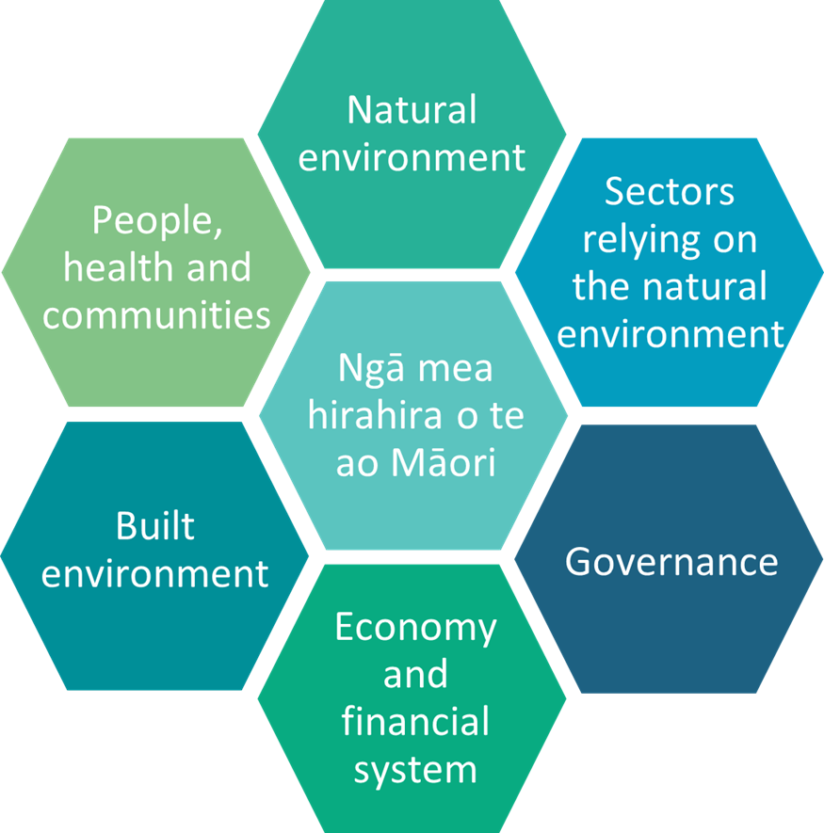

* **Natural environment** – coastal, freshwater, marine and land-based biodiversity and environments.
* **People, health and communities** – people's identity, health, sense of community and social norms, and cultural values and traditions.
* **Ngā mea hirahira o te ao Māori (things of importance in te ao Māori)** – Māori interests and investments, health and wellbeing, culture and practices.
* **Sectors relying on the natural environment** – primary sectors, tourism and energy generation.
* **Built environment** – buildings, urban spaces and infrastructure.
* **Economy and financial system** – production, distribution, trade and consumption of goods and services, economic costs, and finance and insurance markets.
* **Governance** – governing architecture and processes of interaction and decision-making that exist in and between governments, economic and social institutions.

We acknowledge these seven domains are somewhat arbitrary, as risks can span multiple topics and may be interconnected – that is, risks from one domain will flow through to risks in other domains.

## Section 3: Questions

This section sets out the questions we have used in our online form.

**You do not need to answer every question –** if any of them are not relevant to you, please feel free to skip them.

Wherever possible, please use the online form to submit your responses. If you are unable to use the form and will be sending evidence by email or post, please provide your answers to these questions in your submission or email/letter. Doing this will help us to analyse and categorise your evidence.

If your evidence relates only to climate risks **or** actions, please only complete the relevant set of questions. If it relates to both risks and actions, please complete both sets of questions.

If you are providing multiple pieces of evidence that all relate to the same locations and topics, you only need to answer these questions once. If you are providing multiple pieces of evidence that relate to different things, please answer the relevant questions for each piece of evidence.

### Questions about climate risks

|  |  |  |
| --- | --- | --- |
| Question | | |
| **1.01** | Upload a file | If you would like to upload your evidence as a file, please do so on our [engagement website](https://haveyoursay.climatecommission.govt.nz/comms-and-engagement/call-for-evidence-nccra2026)[4]. Please make sure your file is under 25 MB.  If you are uploading several files that all relate to the same thing, please upload them as a single ZIP file. If you are uploading several files that relate to different things, you will need to make multiple submissions. |
| **1.02** | Share a link | If your evidence is already published online, please share the URL where it can be found. However, if a login or subscription is required to access the evidence, please also upload or send the file. |
| **1.03** | Short description of this evidence | Please provide a short description (one or two sentences) to help us understand what your evidence relates to. |
| **1.04** | Topics this evidence relates to | In carrying out this risk assessment, we are considering risks and actions to address risks across seven interconnected domains. For more information about these domains, see Section 2 of this document.  Please select **up to three** **domains** your evidence most relates to.  Natural environment  People, health and communities  Ngā mea hirahira o te ao Māori (things of importance in te ao Māori)  Sectors relying on the natural environment  Built environment  Economy and financial system  Governance |
| **1.05** | Climate hazards this evidence relates to | Risks may flow from one or more climate hazards. Please select **up to three hazards** this evidence relates to.  Sea level rise and coastal flooding  River and surface flooding  Shoreline change and coastal erosion  Storms, and extreme rain and wind  Changing rain and wind patterns  Heatwaves, cold snaps and rising average temperatures  Drought and dry spells  Wildfires and changing fire weather  Ocean warming and acidification  Landslides  Other (please specify below)  If you selected 'other', please specify: |
| **1.06** | Cross-cutting themes this evidence relates to | You may have evidence that is of a cross-cutting nature, and relates to many domains and many hazards.  If so, please select the **main** **cross-cutting themes** this evidence relates to.  If you do not know, please leave this blank.  The physical science basis, including climate observations and projections for Aotearoa New Zealand  Mātauranga Māori and traditional knowledge and observations  Cascading risks, where impacts interact and domino to have broader consequences  Tipping points and critical thresholds  Other (please specify)  If you selected 'other', please specify: |
| **1.07** | Date of evidence | Please indicate the date that this evidence was released, generated or collected. If you don't know the exact date, please provide an estimate.  *Day (dd) – Month (mm) – Year (yyyy)* |
| **1.08** | Type of information | Please select the **main** **type of evidence** this evidence is.  Peer reviewed journal article  Research reports  Modelling / data / tools  Photo / video / audio / podcast  Mātauranga Māori  Lived experience, observations, and localised insights  Climate-related risk assessments and disclosures  Other (please specify)  If you selected 'other', please specify: |
| **1.09** | Location(s) this evidence relates to | Does your evidence relate to Aotearoa New Zealand as a whole, or specific location(s)?  National  Specific location(s)  If your evidence relates to specific locations, please provide more details below. You do not need to answer any or all of the following location-based questions – please only select the options that you think best describe your data. |
| **1.10** | Specific location: Regions | If your evidence relates to specific region(s), please select those that apply:  Northland | Te Tai Tokerau  Auckland | Tāmaki-makau-rau  Waikato  Bay of Plenty | Te Moana-a-Toi  Gisborne | Te Tairāwhiti  Hawke’s Bay | Te Matau-a-Māui  Taranaki  Manawatū-Whanganui  Wellington | Te Whanga-nui-a-Tara  Tasman | Te Tai-o-Aorere  Nelson | Whakatū  Marlborough | Te Tauihu-o-te-waka  West Coast | Te Tai Poutini  Canterbury | Waitaha  Otago | Ōtākou  Southland | Murihiku |
| **1.11** | Specific location: Territories / districts | If your evidence relates to specific territories or districts, please select those that apply:  Far North  Whangārei  Kaipara  Auckland  Thames-Coromandel  Hauraki  Waikato  Matamata-Piako  Hamilton  Waipa  Ōtorohanga  South Waikato  Waitomo  Taupō  Western Bay of Plenty  Tauranga  Rotorua  Whakatāne  Kawerau  Ōpōtiki  Gisborne  Wairoa  Hastings  Napier  Central Hawke’s Bay  New Plymouth  Stratford  South Taranaki  Ruapehu  Whanganui  Rangitikei  Manawatū  Palmerston North  Tararua  Horowhenua  Kāpiti Coast  Porirua  Upper Hutt  Lower Hutt  Wellington  Masterton  Carterton  South Wairarapa  Tasman  Nelson  Marlborough  Buller  Grey  Westland  Kaikōura  Hurunui  Waimakariri  Christchurch  Selwyn  Ashburton  Timaru  Mackenzie  Waimate  Chatham Islands  Waitaki  Central Otago  Queenstown–Lakes  Dunedin  Clutha  Southland  Gore  Invercargill |
| **1.12** | Specific location: Draw or describe location | If your evidence relates to specific locations that do not align with the categories above, or if you would like to provide more detail, you can do so either:   * By drawing location(s) on an interactive map [in our online form](https://haveyoursay.climatecommission.govt.nz/comms-and-engagement/call-for-evidence-nccra2026/consultation/subpage.2024-11-27.1852707357/) * By describing location(s) using text |

### Questions about actions to address climate risks

|  |  |  |
| --- | --- | --- |
| Question | | |
| **2.01** | Upload a file | If you would like to upload your evidence as a file, please do so on our [engagement website](https://haveyoursay.climatecommission.govt.nz/comms-and-engagement/call-for-evidence-nccra2026/consultation/subpage.2024-11-27.1852707357/)[5]. Please make sure your file is under 25 MB.  If you are uploading several files that all relate to the same thing, please upload them as a single ZIP file. If you are uploading several files that relate to different things, you will need to make multiple submissions. |
| **2.02** | Share a link | If your evidence is already published online, please share the URL where it can be found. However, if a login or subscription is required to access the evidence, please also upload or send the file. |
| **2.03** | Short description of this evidence | Please provide a short description (one or two sentences) to help us understand what your evidence relates to. |
| **2.04** | Topics this evidence relates to | In carrying out this risk assessment, we are considering risks and actions to address risks across seven interconnected domains. For more information about these domains, see Section 2 of this document.  Please select **up to three** **domains** your evidence most relates to:  Natural environment  People, health and communities  Ngā mea hirahira o te ao Māori (things of importance in te ao Māori)  Sectors relying on the natural environment  Built environment  Economy and financial system  Governance |
| **2.05** | Type of action | Please select the **type(s) of action** this evidence relates to.  Risk assessment – including at iwi/hapū, sectoral, local, or regional scale  Sectoral climate scenarios and action plans  Government policy, processes, rules and standards  Regional and district long-term planning  Emergency management  Funding mechanisms / grant schemes  Community adaptation planning process  Asset planning and management  Environmental management  Data, information, guidance and tools  Engagement and outreach with communities and mana whenua  Specific project or action to reduce climate risk  Other (please specify)  If you selected 'other', please specify: |
| **2.06** | Date of evidence | Please indicate the date that this evidence was released, generated or collected. If you don't know the exact date, please provide an estimate.  *Day (dd) – Month (mm) – Year (yyyy)* |
| **2.07** | Type of information | Please select the **main** **type of evidence** this evidence is.  Peer reviewed journal article  Research reports  Modelling / data / tools  Photo / video / audio / podcast  Mātauranga Māori  Lived experience, observations, and localised insights  Climate-related risk assessments and disclosures  Other (please specify)  If you selected 'other', please specify: |
| **2.08** | Location(s) this evidence relates to | Does your evidence relate to Aotearoa New Zealand as a whole, or specific location(s)?  National  Specific location(s)  If your evidence relates to specific locations, please provide more details below. You do not need to answer any or all of the following location-based questions – please only select the options that you think best describe your data. |
| **2.09** | Specific location: Regions | If your evidence relates to specific region(s), please select those that apply:  Northland | Te Tai Tokerau  Auckland | Tāmaki-makau-rau  Waikato  Bay of Plenty | Te Moana-a-Toi  Gisborne | Te Tairāwhiti  Hawke’s Bay | Te Matau-a-Māui  Taranaki  Manawatū-Whanganui  Wellington | Te Whanga-nui-a-Tara  Tasman | Te Tai-o-Aorere  Nelson | Whakatū  Marlborough | Te Tauihu-o-te-waka  West Coast | Te Tai Poutini  Canterbury | Waitaha  Otago | Ōtākou  Southland | Murihiku |
| **2.10** | Specific location: Territories / districts | If your evidence relates to specific territories or districts, please select those that apply:  Far North  Whangārei  Kaipara  Auckland  Thames-Coromandel  Hauraki  Waikato  Matamata-Piako  Hamilton  Waipa  Ōtorohanga  South Waikato  Waitomo  Taupō  Western Bay of Plenty  Tauranga  Rotorua  Whakatāne  Kawerau  Ōpōtiki  Gisborne  Wairoa  Hastings  Napier  Central Hawke’s Bay  New Plymouth  Stratford  South Taranaki  Ruapehu  Whanganui  Rangitikei  Manawatū  Palmerston North  Tararua  Horowhenua  Kāpiti Coast  Porirua  Upper Hutt  Lower Hutt  Wellington  Masterton  Carterton  South Wairarapa  Tasman  Nelson  Marlborough  Buller  Grey  Westland  Kaikōura  Hurunui  Waimakariri  Christchurch  Selwyn  Ashburton  Timaru  Mackenzie  Waimate  Chatham Islands  Waitaki  Central Otago  Queenstown–Lakes  Dunedin  Clutha  Southland  Gore  Invercargill |
| **2.11** | Specific location: Draw or describe location | If your evidence relates to specific locations that do not align with the categories above, or if you would like to provide more detail, you can do so either:   * By drawing location(s) on an interactive map in [our online form](https://haveyoursay.climatecommission.govt.nz/comms-and-engagement/call-for-evidence-nccra2026/consultation/subpage.2024-11-27.1852707357/) * By describing location(s) using text |

### Thank you

Thank you for taking the time to submit your evidence. We appreciate your participation. The evidence you share will help to make our work stronger.

If you would like to receive updates as this work progresses, please sign up to our mailing list for this project: <<https://climatecommission.govt.nz/nccra-updates>>

If you have any questions related to this document or the call for evidence, please email [haveyoursay@climatecommission.govt.nz](mailto:haveyoursay@climatecommission.govt.nz)

1. https://haveyoursay.climatecommission.govt.nz/comms-and-engagement/call-for-evidence-nccra2026/
2. https://haveyoursay.climatecommission.govt.nz/comms-and-engagement/call-for-evidence-nccra2026/user_uploads/2024-11-28-nccra-protected-consent-form.docx
3. https://environment.govt.nz/what-government-is-doing/areas-of-work/climate-change/adapting-to-climate-change/first-national-climate-change-risk-assessment-for-new-zealand/
4. https://haveyoursay.climatecommission.govt.nz/comms-and-engagement/call-for-evidence-nccra2026
5. https://haveyoursay.climatecommission.govt.nz/comms-and-engagement/call-for-evidence-nccra2026/